z'SnfkmfF6f /fli6«o lgs'~h If]qdf g]kfns} nflu gofF k|hfltsf] r/f clen]v ul/Psf] ;DaGwdf k|]z lj1KtL
z'SnfkmfF6f /fli6«o lgs'~h If]qaf6 g]kfns} nflu gofF k|hfltsf] r/f clen]v ul/Psf] 5 . z'SnfkmfF6f /fli6«o lgs'~h sfof{no / /fli6«o k|s[lt ;+/If0f sf]if, z'SnfkmfF6f ;+/If0f sfo{qmdn] ;~rfng u/]sf] lgoldt jGohGt' cg';Gwfgsf qmddf pk/f]Qm r/f !# d] @)@# sf lbg lgs'~hsf] pQ/Lefudf /x]sf] sfnfkfgL If]qsf] gbLt6df clen]v ul/Psf] xf] . z'SnfkmfF6f ;+/If0f sfo{qmdsf jGohGt' k|fljlws b]j/fh hf]zLn] pQm r/f clen]v x'g\ . r/f clen]v ul/Psf] If]q ;d'Gb| ;txaf6 @!* ld6/sf] prfOdf /x]sf] 5 .

o;sf] c+u|]hL gfd Lesser Grey Shrike / j}1flgs gfd Lanius minor /x]sf] 5 . of] r/f nflgl8 k+IfL kl/jf/ cGt/ut kb{5 / g]kfnL efiffdf o; kl/jf/ cGt/utsf r/fx?nfO{ eb|fO r/fsf gfdn] lrlgG5 . g]kfndf o;cl3 ^ k|hfltsf eb|fO{ r/fx? clen]v ul/Psf] 5 . eb|fO r/fsf cGo k|hfltx?l;t t'ngf ubf{ z/L/sf] cfsf/df /x]sf] leGgtf, lgwf/ / tfn'df /x]sf] ljz]if sfnf] lrGxx?, sfnf] kv]6fdf /x]sf] Psdfq ;]tf] lrGx cflbsf cfwf/df yk klxrfgsf nflu r/fsf] ljj/0f ;lxt g]kfn k+IfLljb ;+3 cGt/utsf] Rare bird record committee df k7fOPsf] lyof] . pk/f]Qm sldl6n] ;f] r/fsf] lkmN8af6 lnOPsf] kmf]6f] ;lxtsf] ljj/0f /fli6«o÷cGt/f{li6«o VoftLk|fKt k+IfL ljbx?sf] /fo ;lxt gofF k|hfltsf] elg olsg ul/;s]sf] 5 .

n];/ u|] ;|fOs Ps nfdf] b"/L;Dd lar/0f ug]{ lkm/Gt] r/f xf] / ;fOa]l/of b]lv dWo Plzof xF'b} clkm|sf dxfb]z;Dd lar/0f ub{5 . o;cl3 ;g\ @)@) df ef/tsf] k~hfj k|fGtsf] n'lwofgf If]qdf of] k|hflt /]s8{ ul/Psf] kfOPsf] 5 . gofF k|hfltsf] r/f /]s8{ ul/o;+u} g]kfndf r/fsf k|hfltx?sf] ;du| ;+Vof *(@ sfod ePsf] 5 eg z'SnfkmfF6f /fli6«o lgs'~h If]qdf dfq} $^) k|hfltsf] klxrfg ePsf] 5 .

gofF /]s8{ ul/Psf] r/fsf kmf]6f]x?
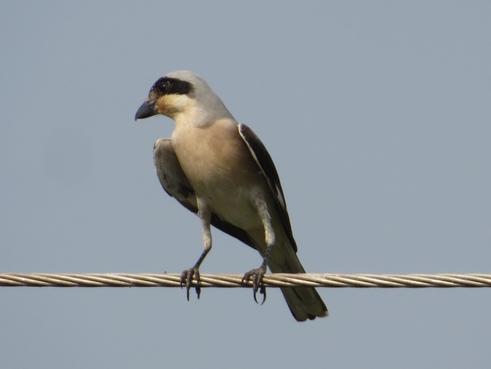 | 